**Arduino project**

**Introduction:**

These days, the agricultural sector is facing enormous challenges as the population grows. To increase the quality and quantity of agricultural production, I believe use of technology in agricultural sector such as sensors is very important.

As it already proves, many farms are turning into more intelligent farming called ‘smart farming’. For this Arduino project, I have developed an application using a thermistor and various other components to create a simple temperature sensor.

**How to set up and run:**

The device I developed consists of an Arduino Uno board, a breadboard, a thermistor, 2 LEDs, 3 resistors and a piezo buzzer. The model of thermistor I used is MF52 which is a NTC (negative coefficient thermistor). This means temperature varies inversely with the resistance in the thermistor. Since the thermistor can measure temperature of surrounding using its resistance, I’ve created a model which lights up LEDs and ring the buzzer when the temperature of the surrounding is higher than the limit values I have set to alarm.

To light up and ring the buzzer, it requires power source, so I connected a wire to 5V pin and GND (ground) pin to flow current. LEDs and the buzzer are connected to digital pins on Arduino board as I want to turn on(HIGH,1) or off(LOW,0). However, the thermistor is connected to analog pin.

When the current flows through the thermistor, the voltage (between 0 and 5) varies depending on the value of resistance in the thermistor. Using analogRead() function, I found the input analog value from the thermistor. The analog input value received is the value of voltage (0-5V) for thermistor but in analog value (0-1023). To find the value of resistance of the thermistor, I had to find the value of voltage. To do that, I used equation **Vo=(analog reading*5)/1024.0** where Vo is the value of the voltage between 0 and 5. Then, I calculated the value of the resistance by using the equation:

**Vo = V(5V)*10000/(10000+R) and rearranged it to the subject of R.**

When the value of resistance is found, I used ‘Stein Hart’ equation to calculate the temperature in kelvin and converted into Celsius degree.

T0: 25 Celcius degree in kelvin

T: temperature of surrounding

R: resistance in thermistor

R0: 10000

n: coefficient of thermistor

On Arduino, the function log is log **base e**. In other word, **ln**.

**Stein Hart equation: 1/T= A+ B ln(R)+C(ln(R))^3**

**But it can be also expressed as below**

**Stein Hart equation: 1/T = 1/T0 + (1/n)*ln(R/R0)**

Once the value of temperature is received to Arduino board, it compares with the limit values I have set in the code. If it exceeds, the LEDs blink and the piezo buzzer makes sound depending on the frequency of the note I have set on the code.

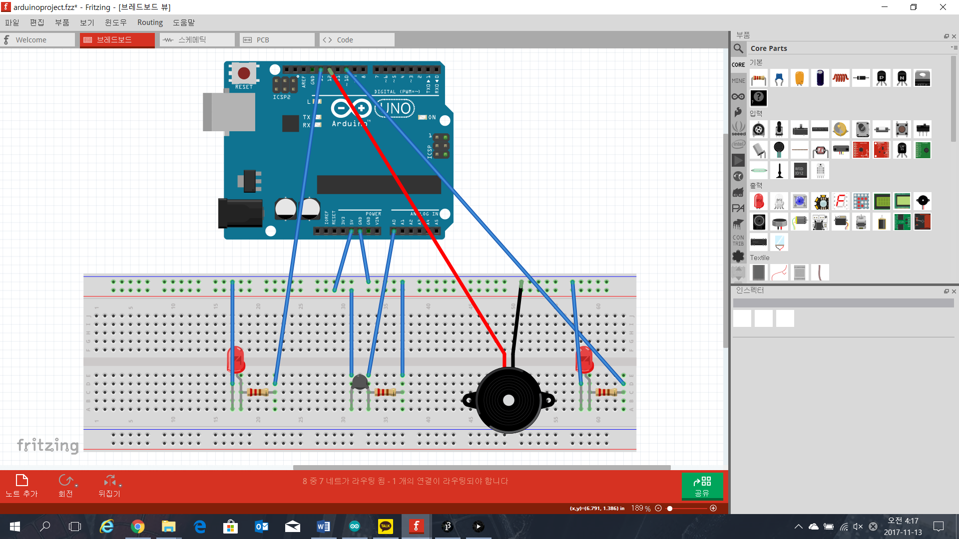

**Image of my final product (drawn using Fritzing software)**

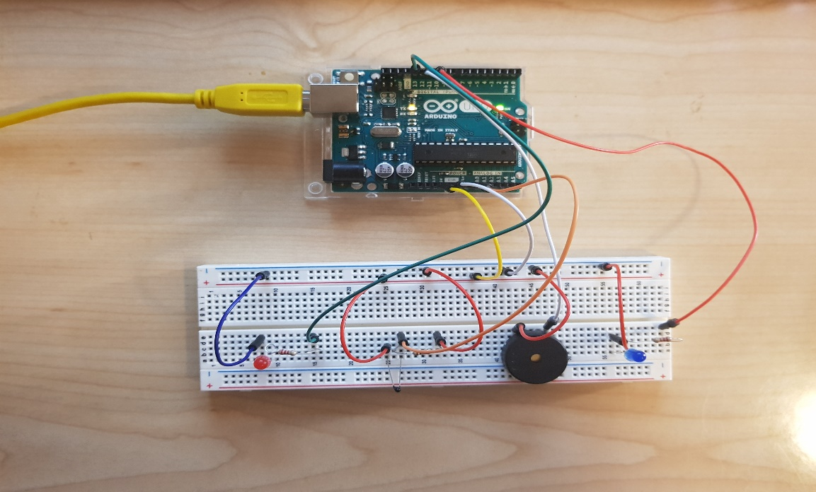

**Image of my final product**

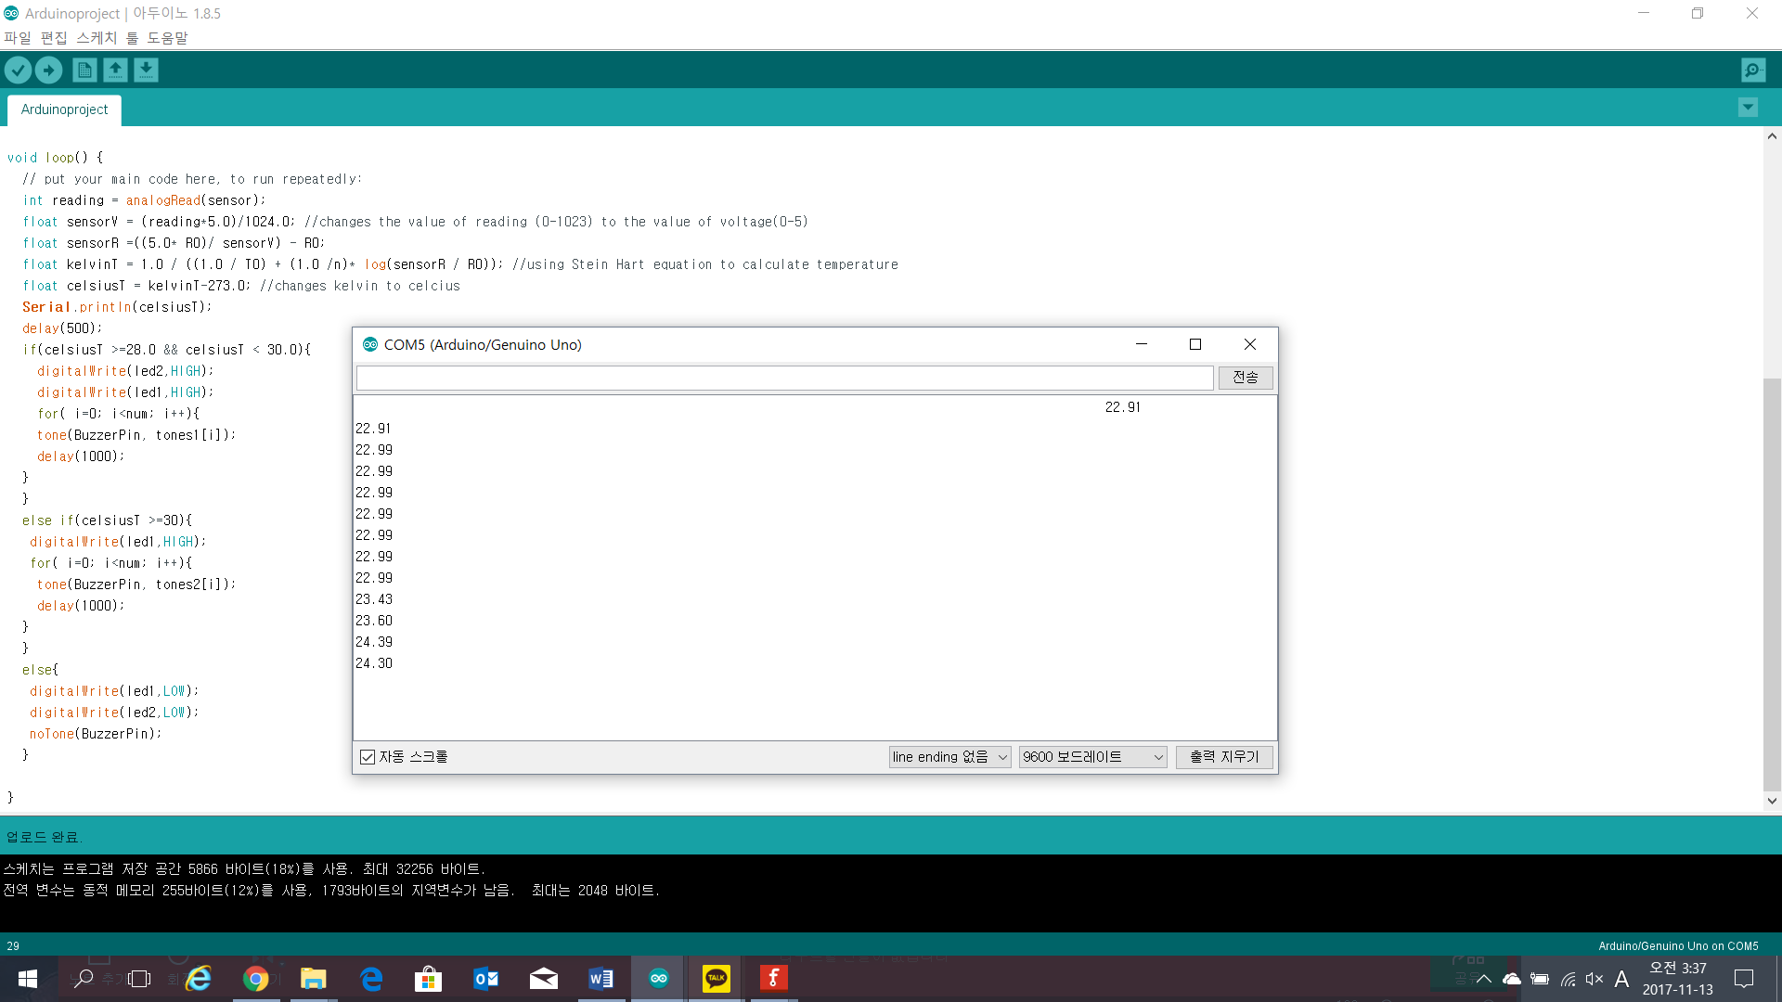

**Screenshot of serial port when running**

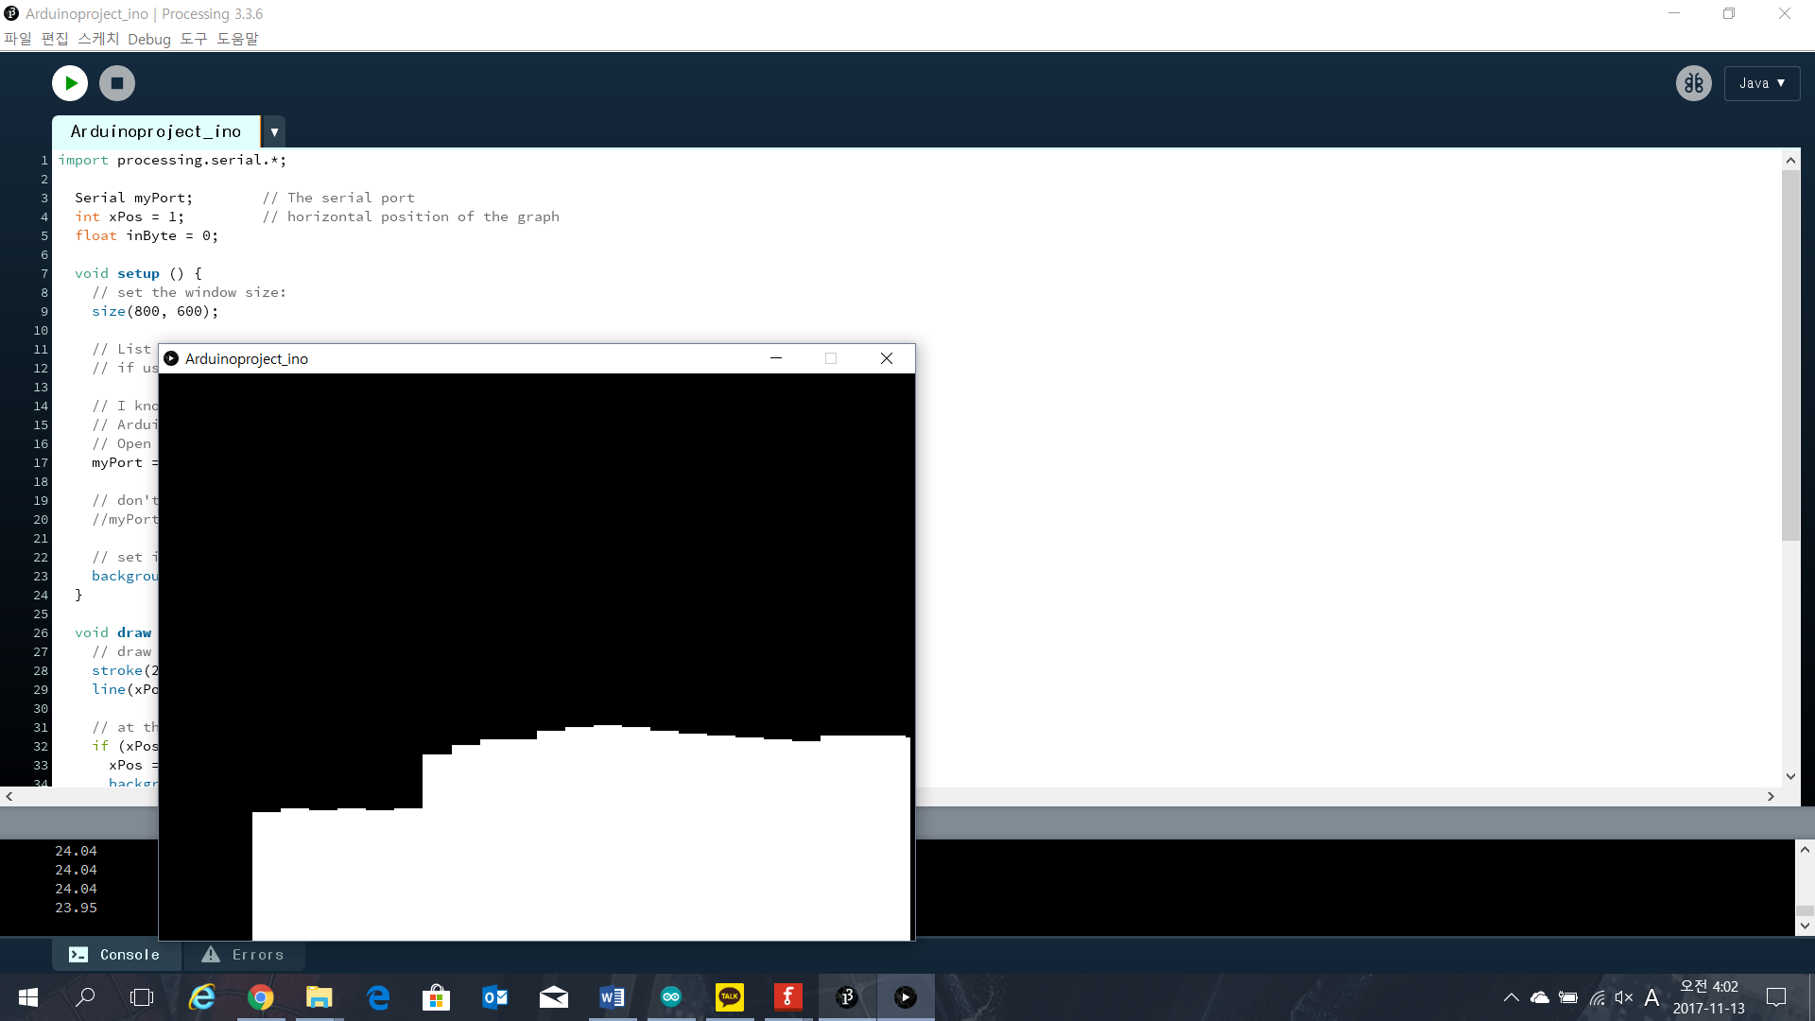

**Screenshot of graph plotting using the data received from Arduino and thermistor**

I have set the minimum value on y-axis to be 15 and maximum value to be 40 by using

inByte = map(inByte, 15, 40, 0, height);. This makes more noticeable difference in the graph when the temperature changes compare to when the graph has minimum value of y-axis, 0.

**Reference**

1. <https://arduining.com/2013/08/05/arduino-and-processing-graph-example/>
2. <http://www.eaa.net.au/PDF/Hitech/MF52type.pdf>
3. <http://cafe.naver.com/openrt/6370>